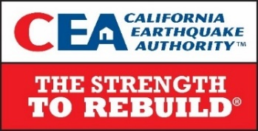
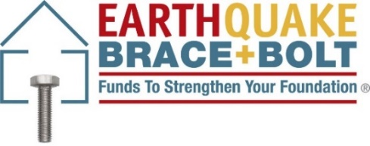

IMMEDIATE RELEASE Contact: D’Anne Ousley, (916) 769-5766 June 18, 2021 Earthquake Brace + Bolt dousley@calquake.com

More Than 15,000 California Homes Protected from Catastrophic Earthquake Damage with Seismic Retrofit Program

Earthquake Brace + Bolt program offers grants of up to $3K to California homeowners for seismic retrofits of vulnerable homes
Click HERE for video celebrating 15,000 retrofits

(SACRAMENTO) The Earthquake Brace + Bolt program is celebrating a significant milestone as more than 15,000 California homeowners have completed a seismic retrofit of their house to help strengthen it and protect their investment before the next damaging earthquake.

Since the program launched in 2013, EBB has helped California homeowners in high-risk areas offset the cost of a seismic retrofit by offering grants of up to $3,000. With as many as 1.2 million vulnerable homes and a significant risk of a major quake in the future, strengthening California homes is crucial for a safe, more resilient state.

“Proactively protecting homes through building-code-compliant retrofits and ensuring proper insurance coverage are vital in an earthquake-prone state with a tight housing supply,” said California Earthquake Authority (CEA) CEO Glenn Pomeroy. “CEA is continually seeking additional grant-funding sources so that more Californians can join the 15,000 that have been able to retrofit their home with EBB.”

According to the California Geological Survey, each year, California generally gets two or three earthquakes large enough to cause moderate damage to structures (magnitude 5.5 and higher). EBB provides grants to homeowners whose houses are vulnerable to earthquake damage due to their type of construction. Houses that qualify typically were built before1980, have a raised concrete foundation and may have wood-framed walls in the crawl space under the house.

“Many homeowners don’t realize how fragile their house is until it’s too late,” said CEA Chief Mitigation Officer and EBB Executive Director Janiele Maffei. “By completing a seismic retrofit, homeowners can lessen the potential damage a large quake can cause.”

Page 1 of 2
How to Apply for EBB Grants
EBB registration is currently closed. However, interested California homeowners are strongly encouraged to sign-up to receive updates from EBB about where and when the next registration will open. For detailed program information and to see if your home is eligible for an EBB grant, visit EarthquakeBraceBolt.com. A full list of eligible ZIP Codes and a searchable directory with more than 1,000 licensed, FEMA-trained contractors is available.

About Earthquake Brace + Bolt (EBB)
Established by the California Residential Mitigation Program (CRMP), EBB offers up to $3,000 to help California homeowners retrofit their house to reduce potential damage from earthquakes. Residential seismic retrofits bolt the house to its foundation and add bracing, if required, around the perimeter of the crawl space making it more resistant to earthquake activity. For more information, please visit http://www.EarthquakeBraceBolt.com.

About the California Residential Mitigation Program (CRMP)
CRMP was established in 2011 to help Californians strengthen their homes against damage from earthquakes. CRMP is a joint powers authority created by the California Earthquake Authority and the California Governor’s Office of Emergency Services. For more information, please visit http://www.CaliforniaResidentialMitigationProgram.com.

About the California Earthquake Authority (CEA)
The California Earthquake Authority (CEA) is a not-for-profit public instrumentality of the state of California that has two distinct roles: Since 1996, CEA has provided residential earthquake insurance while educating Californians about earthquake risk and helping them reduce their risk of earthquake losses through residential mitigation. Since 2019, CEA also has administered the Wildfire Fund, a catastrophe fund that provides a source of funding for payment of claims arising from a wildfire caused by any large electrical utility company that meets the legal requirements for participation in the fund.

VIDEO: Link to 15k Video

VIDEO: EBB Testimonials

# # #

